--1

--For Austin

-- to find the average of acceptance rate, response rate, host has profile pic and host identity verified of Host and super host in Austin

Select host_is_superhost, Round((AVG(host_acceptance_rate)),2) as AVG_of_AcceptanceRate, Round((AVG(host_response_rate)),2) as AVG_of_ResponseRate,

count(case when host_has_profile_pic=1 then 1 end) as CNT_of_Host_has_Profile_Pic,

count(case when host_identity_verified=1 then 1 end) as CNT_of_Host_identity_verified

From [dbo].[host_austin_df]

where host_has_profile_pic is not null and host_identity_verified is not null

Group by host_is_superhost

Order by host_is_superhost

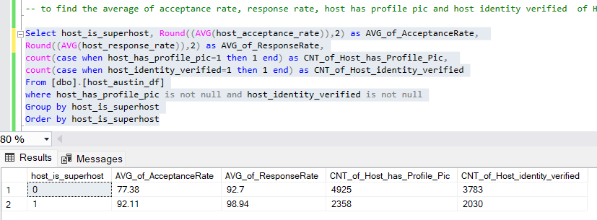

--to find the count of Instant booking and review scores values in Austin based on host and super host

Select host_is_superhost, Count(instant_bookable) as CNT_of_Instant_Booking , AVG(Distinct review_scores_value) as AVG_Rating

From [dbo].[listing_austin_df] as A

Inner join [dbo].[host_austin_df] as B on A.host_id = B.host_id

where host_acceptance_rate is not null

Group by host_is_superhost

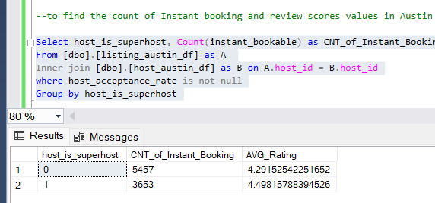

--to find the number of bookings per month

Select host_is_superhost , Month(date) as Month,

Count(Date)/30 as Average_Bookings

from [dbo].[host_austin_df] as A

Inner join [dbo].[listing_austin_df] as B on A.host_id= B.host_id

Inner join [dbo].[df_austin_availability] as C on C.listing_id= B.id

Where available = 'False' and host_is_superhost is not null

Group by Month(date) ,host_is_superhost

order by host_is_superhost, Month(date)

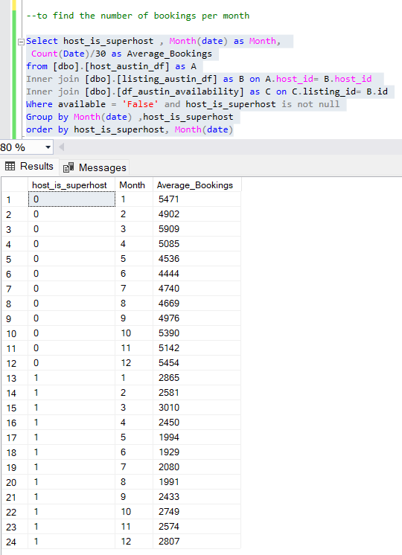

-- for Dallas

-- to find the average of acceptance rate, response rate, host has profile pic and host identity verified of Host and super host in Dallas

Select host_is_superhost, Round((AVG(host_acceptance_rate)),2) as AVG_of_AcceptanceRate, Round((AVG(host_response_rate)),2) as AVG_of_ResponseRate,

count(case when host_has_profile_pic=1 then 1 end) as CNT_of_Host_has_Profile_Pic,

count(case when host_identity_verified=1 then 1 end) as CNT_of_Host_identity_verified

From [dbo].[host_dallas_df]

where host_has_profile_pic is not null and host_identity_verified is not null

Group by host_is_superhost

Order by host_is_superhost

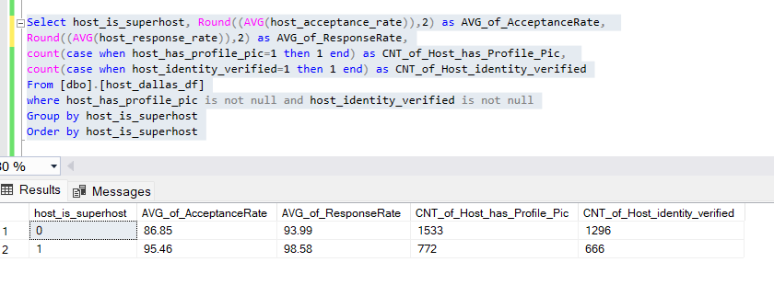

--to find the count of Instant booking and review scores values in Austin based on host and super host in Dallas

Select host_is_superhost, Count(instant_bookable) as CNT_of_Instant_Booking , AVG(Distinct review_scores_value) as AVG_Rating

From [dbo].[listing_dallas_df] as A

Inner join [dbo].[host_dallas_df] as B on A.host_id = B.host_id

where host_acceptance_rate is not null

Group by host_is_superhost

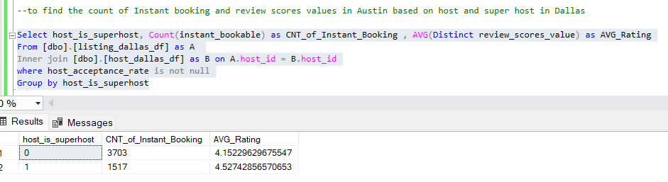

--to find the number of bookings per month in Dallas

Select host_is_superhost , Month(date) as Month,

Count (Date)/30 as Average_Bookings

from [dbo].[host_dallas_df] as A

Left join [dbo].[listing_dallas_df] as B on A.host_id= B.host_id

Left join [dbo].[df_dallas_availability] as C on C.listing_id= B.id

Where available = 'False' and host_is_superhost is not null

Group by Month(date) ,host_is_superhost

order by host_is_superhost, Month(date)

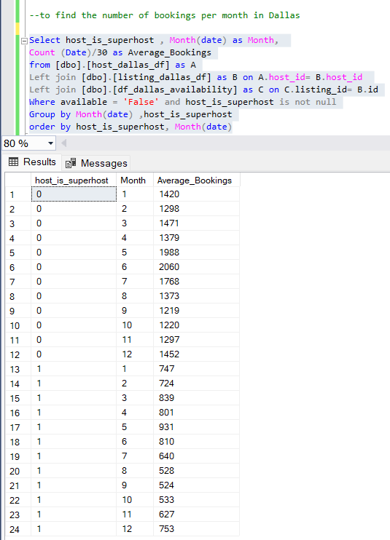

--2

--For Austin

--to find the find the criteria to become super host and the average of them in Ausitn

Select host_is_superhost, Round((AVG(host_acceptance_rate)),2) as AVG_of_AcceptanceRate, Round((AVG(host_response_rate)),2) as AVG_of_ResponseRate,

AVG(review_scores_value) as AVG_Rating

From [dbo].[host_austin_df] As A

Inner join [dbo].[listing_austin_df] as B on A.host_id= B.host_id

where host_acceptance_rate is not null

Group by host_is_superhost

order by host_is_superhost desc;

--For Dallas

----to find the find the criteria to become super host and the average of them in Dallas

Select host_is_superhost, Round((AVG(host_acceptance_rate)),2) as AVG_of_AcceptanceRate, Round((AVG(host_response_rate)),2) as AVG_of_ResponseRate,

AVG(review_scores_value) as AVG_Rating

From [dbo].[host_dallas_df] As A

Inner join [dbo].[listing_dallas_df] as B on A.host_id= B.host_id

where host_acceptance_rate is not null

Group by host_is_superhost

order by host_is_superhost desc;

--To become superhost AVG acceptance rate should be > 91%

--To become superhost AVG response rate should be > 98%

--To become superhost AVG rating should be > 4.81

--3

--Analysing comments for austin

Select host_is_superhost ,

Sum(Case when comments like '%recommended%' Then 1 End) as recommended,

Sum(Case when comments like '%gracious%' Then 1 End) as gracious,

Sum(Case when comments like '%wonderful%' Then 1 End) as wonderful,

Sum(Case when comments like '%beautiful%' Then 1 End )as Beautiful,

Sum(Case when comments like '%great%' Then 1 End) as Great,

Sum(Case when comments like '%Comfortable%' Then 1 End) as Comfortable,

Sum(Case when comments like '%Convenient%' Then 1 End) as Convenient,

Sum(Case when comments like '%Available%' Then 1 End) as Available,

Sum(Case when comments like '%Friendly%' Then 1 End) as Friendly,

Sum(Case when comments like '%Poor%' Then 1 End) as Poor

from [dbo].[review_austin_df] as A

Inner join [dbo].[listing_austin_df] as B on A.listing_id = B.id

Inner join [dbo].[host_austin_df] as C on C.host_id= B.host_id

Where host_is_superhost is not null

Group by host_is_superhost

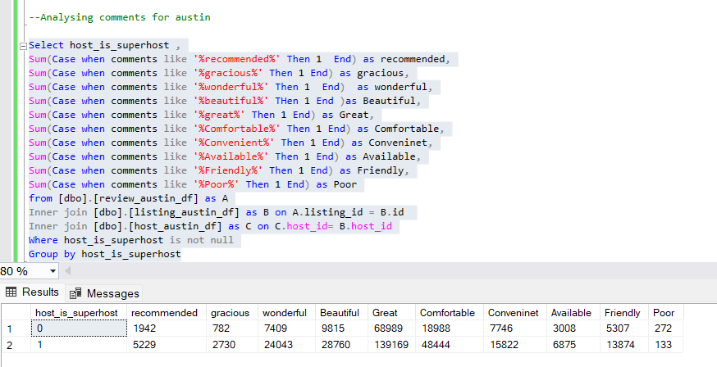

--Analysing comments for Dallas

Select host_is_superhost ,

Sum(Case when comments like '%recommended%' Then 1 End) as recommended,

Sum(Case when comments like '%gracious%' Then 1 End) as gracious,

Sum(Case when comments like '%wonderful%' Then 1 End) as wonderful,

Sum(Case when comments like '%beautiful%' THen 1 End )as Beautiful,

Sum(Case when comments like '%great%' Then 1 End) as Great,

Sum(Case when comments like '%Comfortable%' Then 1 End) as Comfortable,

Sum(Case when comments like '%Convenient%' Then 1 End) as Conveninet,

Sum(Case when comments like '%Available%' Then 1 End) as Available,

Sum(Case when comments like '%Friendly%' Then 1 End) as Friendly,

Sum(Case when comments like '%Poor%' Then 1 End) as Poor

from [dbo].[review_dallas_df] as A

Inner join [dbo].[listing_dallas_df] as B on A.listing_id = B.id

Inner join [dbo].[host_dallas_df] as C on C.host_id= B.host_id

Where host_is_superhost is not null

Group by host_is_superhost

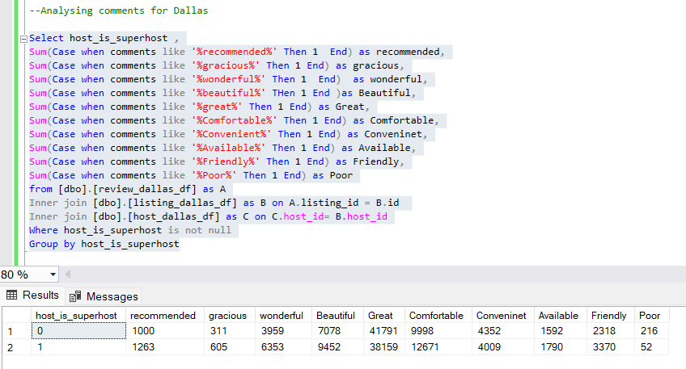

-- 4

--For Austin

--To find super hosts tends to have large property types as compared to other hosts in Austin

Select host_is_superhost,

Sum(Case when property_type like 'Entire guesthouse%' Then 1 End ) as Entire_guesthouse_accomodations,

Sum(Case when property_type like 'Entire townhouse%' Then 1 End ) as Entire_townhouse_accomodations,

Sum(Case when property_type like 'Entire home%' Then 1 End ) as Entire_home_accomodations,

Sum(Case when property_type like 'Entire residential home%' Then 1 End ) as Entire_residential_home_accomodations,

Sum(Case when property_type like 'Private%' Then 1 End ) as Private_accomodations

From [dbo].[listing_austin_df] as A

Inner join [host_austin_df] as B on A.host_id = B.host_id

Where host_is_superhost is not null

Group by host_is_superhost

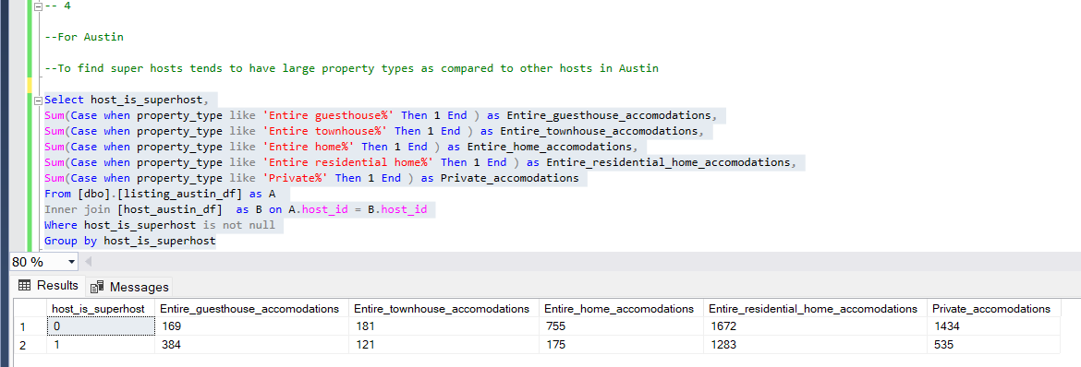

--For Dallas

--To find super hosts tends to have large property types as compared to other hosts in Dallas

Select host_is_superhost,

Sum(Case when property_type like 'Entire guesthouse%' Then 1 End ) as Entire_guesthouse_accomodations,

Sum(Case when property_type like 'Entire townhouse%' Then 1 End ) as Entire_townhouse_accomodations,

Sum(Case when property_type like 'Entire home%' Then 1 End ) as Entire_home_accomodations,

Sum(Case when property_type like 'Private%' Then 1 End ) as Private_accomodations

From [dbo].[listing_dallas_df] as A

Inner join [host_dallas_df] as B on A.host_id = B.host_id

Where host_is_superhost is not null

Group by host_is_superhost

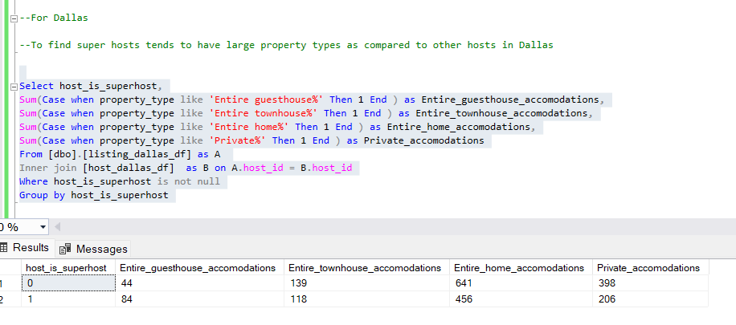

--5

-- For Austin

--Analyze the average price and availability of the listings for the upcoming year between Super Hosts and Other Hosts in Austin

select year(B.date) as year ,C.host_is_superhost, round(avg(A.price),2) as Avg_price from listing_austin_df as A inner join df_austin_availability as B on A.id= B.listing_id inner join host_austin_df as C on A.host_id= C.host_id where year(B.date)is not null and host_is_superhost is not null and B.available='True'

group by C.host_is_superhost, year(B.date)

order by year(B.date),host_is_superhost

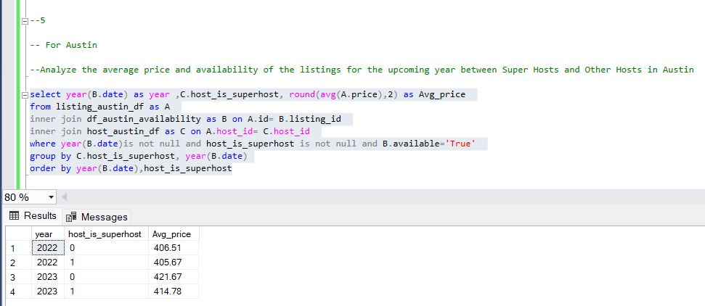

-- For Dallas

--Analyze the average price and availability of the listings for the upcoming year between Super Hosts and Other Hosts in Dallas

select year(B.date) as year ,C.host_is_superhost, round(avg(A.price),2) as Avg_price from listing_dallas_df as A inner join df_dallas_availability as B on A.id= B.listing_id inner join host_dallas_df as C on A.host_id= C.host_id where year(B.date)is not null and host_is_superhost is not null and B.available='True'

group by C.host_is_superhost, year(B.date)

order by year(B.date),host_is_superhost

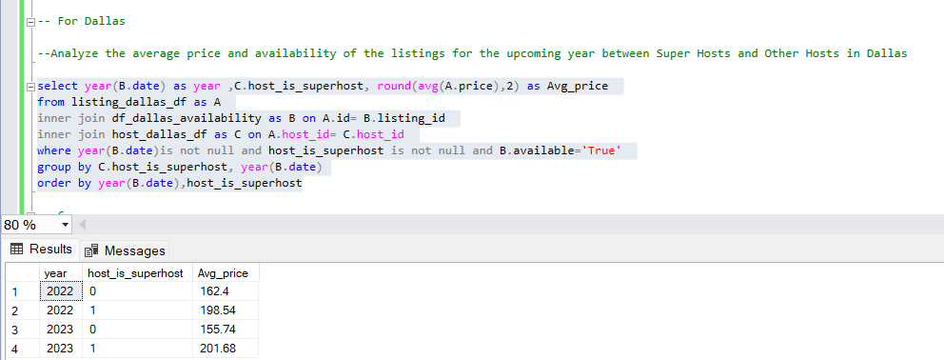

-- 6

--For Austin

--Analyze if there is some difference in above mentioned trends between Local Hosts or Hosts residing in other locations (in Austin)

--a

Select Case when host_location like 'Austin%' Then 'Local_Host' Else 'Foreign_Host' End as Host_Location1,

Round((AVG(host_acceptance_rate)),2) as AVG_of_AcceptanceRate, Round((AVG(host_response_rate)),2) as AVG_of_ResponseRate,

count(case when host_has_profile_pic=1 then 1 end) as CNT_of_Host_has_Profile_Pic,

count(case when host_identity_verified=1 then 1 end) as CNT_of_Host_identity_verified

From [dbo].[host_austin_df]

where host_has_profile_pic is not null and host_identity_verified is not null

Group by Case when host_location like 'Austin%' Then 'Local_Host' Else 'Foreign_Host' End

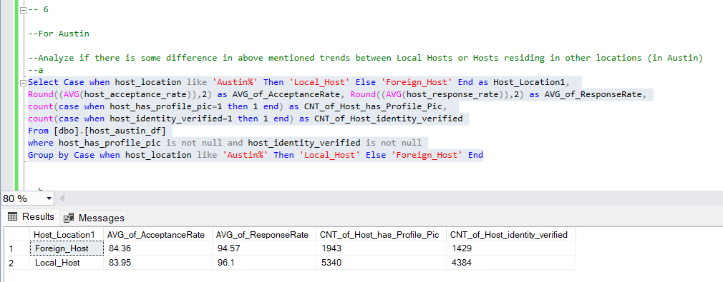

--b

Select Case when host_location like 'Austin%' Then 'Local_Host' Else 'Foreign_Host' End as Host_Location1,

Count(instant_bookable) as CNT_of_Booking , AVG(Distinct review_scores_value) as AVG_Rating

From [dbo].[listing_austin_df] as A

Inner join [dbo].[host_austin_df] as B on A.host_id = B.host_id

where host_acceptance_rate is not null

Group by Case when host_location like 'Austin%' Then 'Local_Host' Else 'Foreign_Host' End

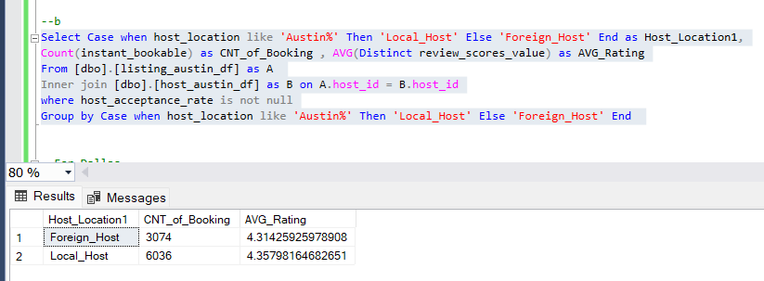

--For Dallas

--Analyze if there is some difference in above mentioned trends between Local Hosts or Hosts residing in other locations (in Dallas)

--a

Select Case when host_location like 'Dallas%' Then 'Local_Host' Else 'Foreign_Host' End as Host_Location1,

Round((AVG(host_acceptance_rate)),2) as AVG_of_AcceptanceRate, Round((AVG(host_response_rate)),2) as AVG_of_ResponseRate,

count(case when host_has_profile_pic=1 then 1 end) as CNT_of_Host_has_Profile_Pic,

count(case when host_identity_verified=1 then 1 end) as CNT_of_Host_identity_verified

From [dbo].[host_dallas_df]

where host_has_profile_pic is not null and host_identity_verified is not null

Group by Case when host_location like 'Dallas%' Then 'Local_Host' Else 'Foreign_Host' End

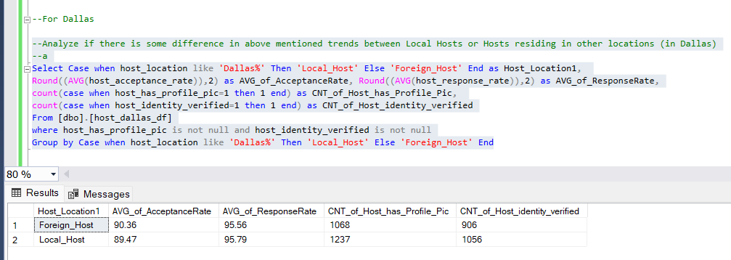

--b

Select Case when host_location like 'Dallas%' Then 'Local_Host' Else 'Foreign_Host' End as Host_Location1,

Count(instant_bookable) as CNT_of_Booking , AVG(Distinct review_scores_value) as AVG_Rating

From [dbo].[listing_dallas_df] as A

Inner join [dbo].[host_dallas_df] as B on A.host_id = B.host_id

where host_acceptance_rate is not null

Group by Case when host_location like 'Dallas%' Then 'Local_Host' Else 'Foreign_Host' End

